Part A
Sketch of the website:
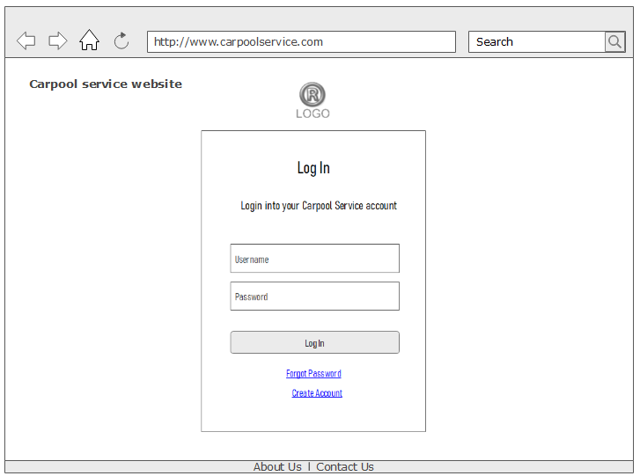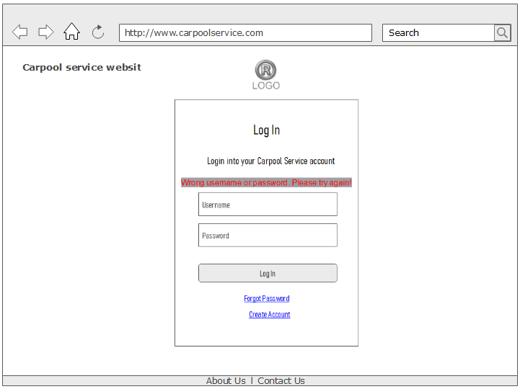

Log in and sign in pages

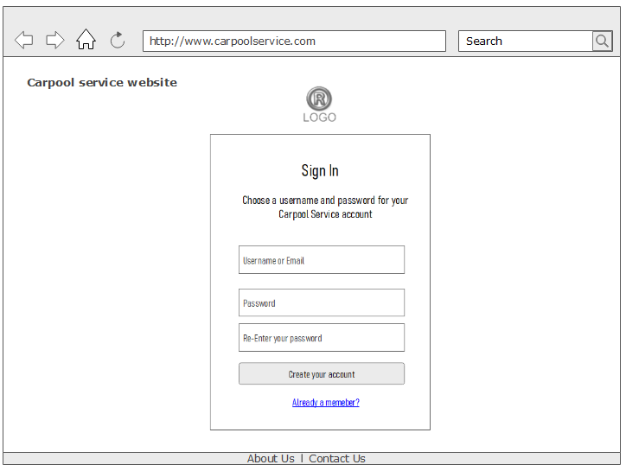
Welcome page
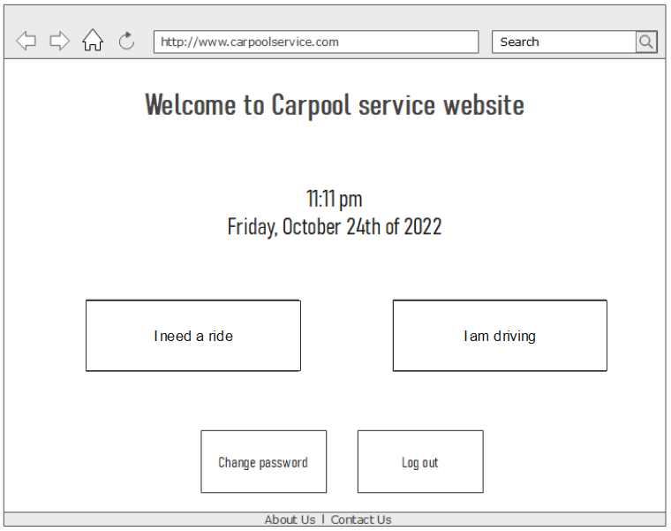
change password page
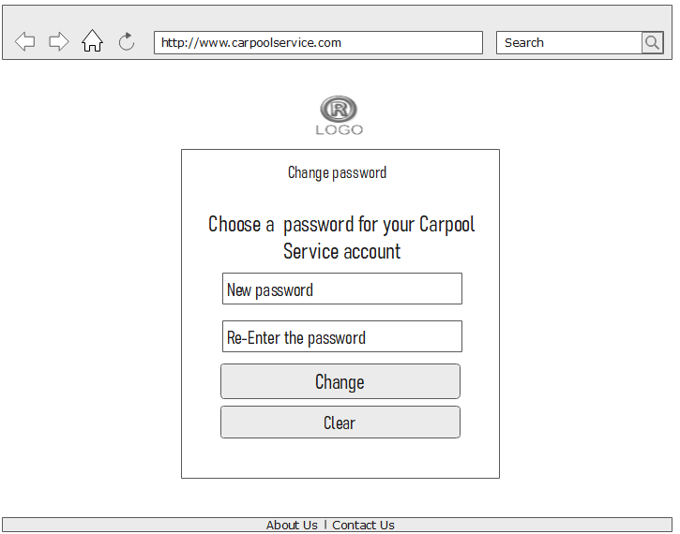

Log out page
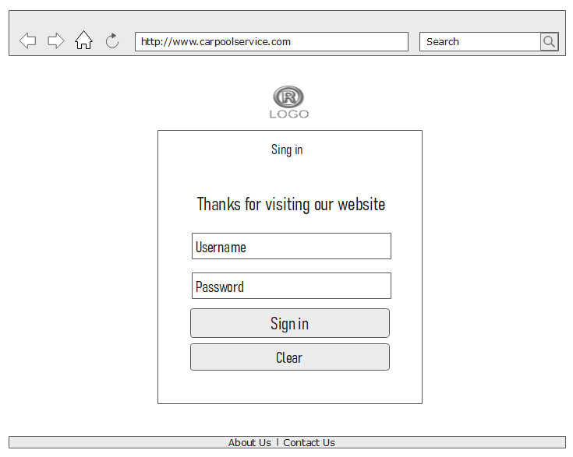
Passenger page
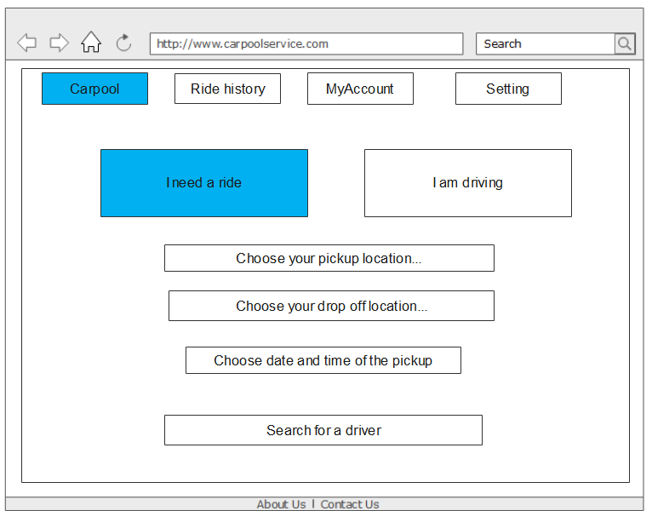
Driver page
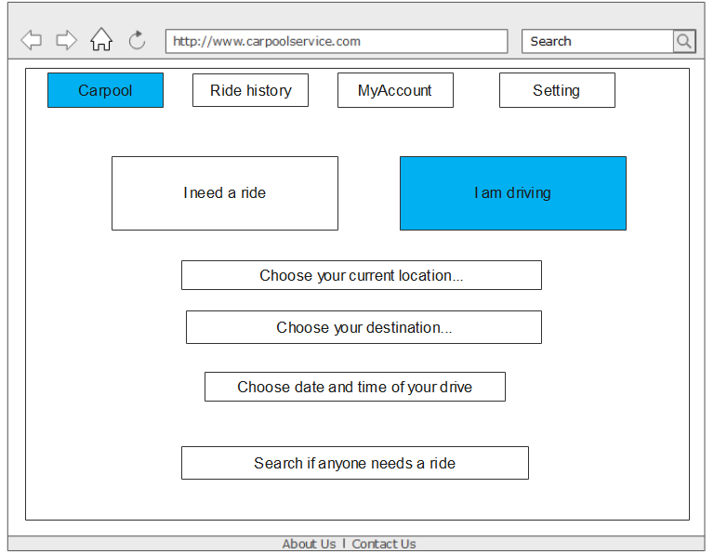

Ride history page:
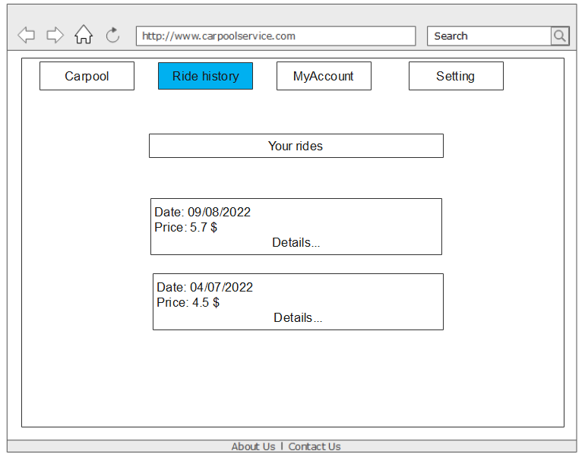
Profile page
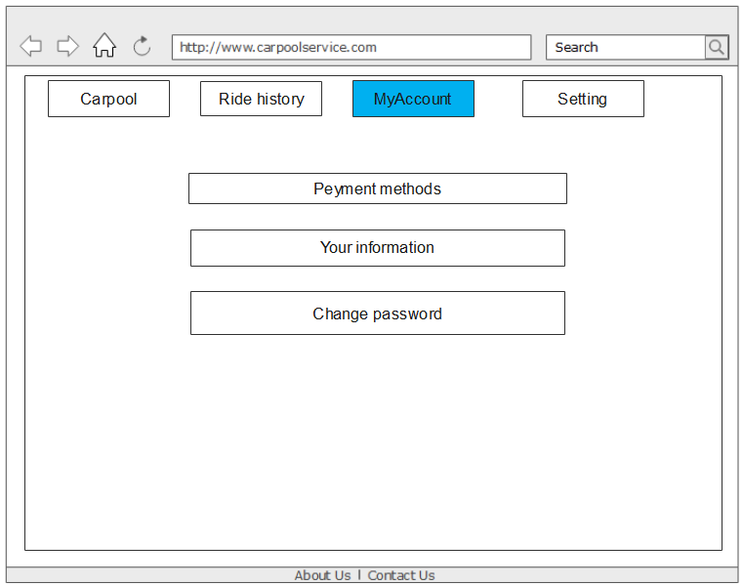

Payment page:
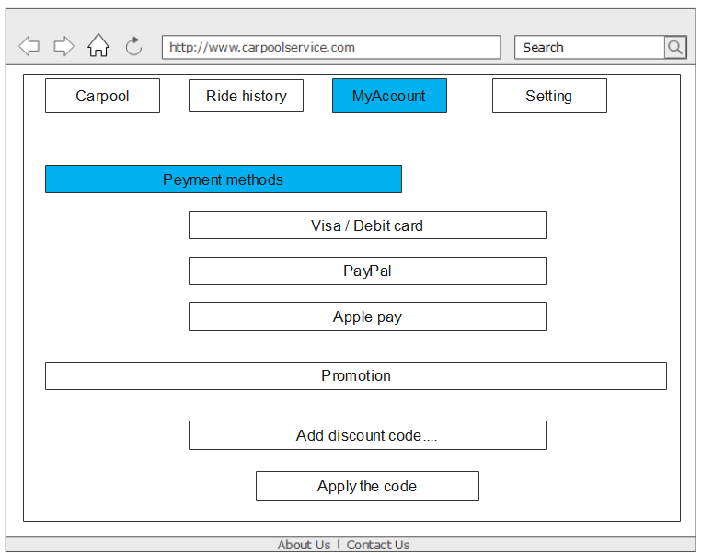

Personal information page:
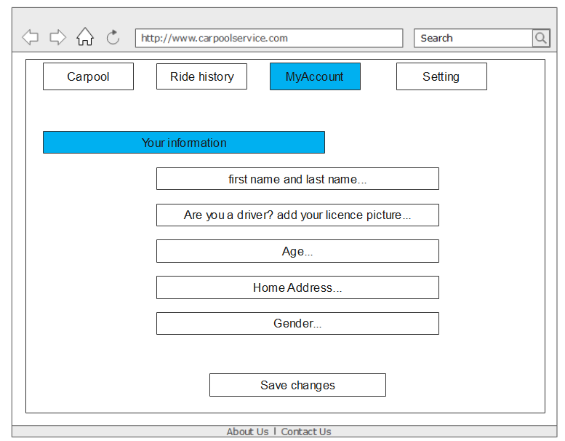
Setting page:
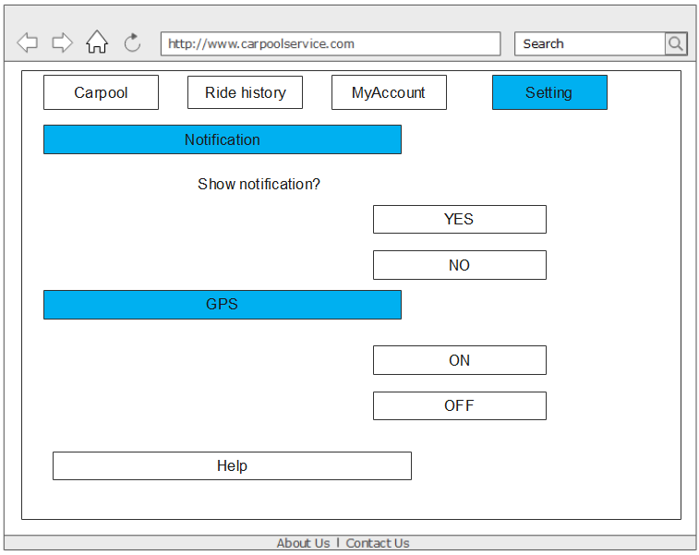
Part B
** (The following is the top 3 use cases ranked in order)
Use Case 1: Log in
Scope: User log in on the web page
Level: user goal
Primary actor: user
Stakeholders and Interests:
- User: Wants fast and easy login, and no errors during login.
- Company: Wants to allow the user to log in and then give them the permission of changing their data in database based on their activity after logging in.
Preconditions: User already has an account in company.
Postconditions: User can use the applications on the website.
Main Success Scenario:
- User enters the website, text boxes for entering passwords and username is shown.
- User enters the username and password.
- Applications of the website is allowed to use for the user.

Extensions:
- The password is wrong
- Tell user that it’s wrong and ask for it again, 4 chances are given
- 4 chances are used and still have the wrong password, stop user from entering password for 5 min.
- Show company’s website for reset the password based on email.
- The username is wrong
- Tell user that it’s wrong and ask for it again, 4 chances are given
- 4 chances are used and still have the wrong username, stop user from entering password for 5 min.
- Show company’s website for reset the username based on email.

Use Case 2: Driver Gets the registered Passenger
Scope: pick-up function of the application
Level: user goal
Primary actors: driver, passenger
Stakeholders and Interests:
- Driver: Wants to know what to do when picking up passenger, and what need to be done when cases like no one show up happens.
- Passenger: Something needs to be done when passengers get picked up, or passenger doesn’t show up.
- Company: needs to make changes based on users’ actions.
Preconditions: Users are identified and Company’s database works fine.
Postconditions: data in company’s database is changed based on users’ reaction.
Main Success Scenario:
- Driver arrives at the passenger’s registered location.
- Passenger gets in the car.
- Passenger confirms that s/he got in the car, Driver confirms that s/he received the passenger.
- When the ride ends, in the respective profiles of passenger & driver, the number of successful rides for driver and success is shown through “+ 1”. It’s a system of rating to indicate the credit of user, and they rate each other or write review based on their opinions and reactions during the ride. With each ride the passenger or driver will receive a plus one to show they arrived on time and in correct location.

Extensions:
- If the passenger is not found at expected location:
- Driver confirms that passenger is absent
- Unsuccessful ride counter for passenger is incremented and it’s shown on the profile of user.
- Passenger won’t receive refund. Driver stops waiting and moves on to the next destination.
- If the Driver is not at the selected location:
- Passenger confirms that Driver is absent
- Unsuccessful ride counter for driver is incremented and it’s shown on the driver profile.
- Passenger stops waiting and is eligible for refund with 20% of the paid fee is the penalty for driver.

Use Case 3: Set a ride on passenger side
Scope: Setting ride application
Level: user goal
Primary actor: passenger
Stakeholders and Interests:
- Passenger: wants to search a desired destination to arrive at a certain time and day, and then sets the ride; or searches for the ride that already exists and match what s/he wants.
- Driver: expects a passenger to find him/her or provide a ride based on the passenger’s need.
Preconditions: All the users are identified, and the input locations are valid on the map, and their payment information are all correct.
Postconditions: Passenger can find or set a ride, and the set ride can be shown for the drivers on the market place.
Main Success Scenario:
- Passenger first search for the ride based on the destination, start from current location or any specific place.
- Find a ride and register the ride, then set a proper start location to get pick up, and pay for it.

Extensions:
- If there is no proper ride after the search
- Passenger request a ride, and set all the information of locations, then get the price for it and pay. Then wait for a driver to accept this ride.
- If there’s no driver who receives the ride with a time frame, return the money to passengers or search again.
Top 3 use cases: use case #1, #2, #3 as these three will be the most common used functions of the application. Passengers will always have to log in and either find/search or provide rideshare service.

Part C
Software architecture: Model-View-Controller (MVC)
MVC model is best fit for this project as there is a heavy dependence on user interaction. As the categories of data to be used by the application is known (i.e., user personal information, location, payment information and so on) it is easy to categorize them into each of model-view-controller levels.
Views level interacts with users through UI, model level stores data and controller processes user requests. This architecture also allows easy modification to the system as addition of update is done independent of the other sections. The development process is also faster following this architecture so product deliver will be faster and maintenance is also not so complicated. Being a mobile/web application, the service should also allow different view for different operating systems, which MVC provides with ease without duplicating data. Furthermore, the architecture pattern is SEO friendly platform which is essential as users would prefer to find their desired destinations accurately and easily based on their locations.
Implementations of use cases:
Use case 1: For login, a database will be used to store information. At first when the user creates the account, their username and password will be recorded in database. The username would be the primary key for the individual account, and once the user enters all the information, the database will confirm weather if the information is correct.
Use case 2: For picking up passengers and getting picked up, the information of the ride that’s stored in the database will be presented for the driver. Based on this, drivers will pick up the passengers at the pick-up locations. Every time a passenger is picked up, and is confirmed by both driver and that passenger, information in the database about the ride will be updated. Also based on the location of driver or the passenger, and the estimated time for the driver to arrive at the pickup location, the system will update the user’s information.
When the driver doesn’t arrive at the pickup point after a certain amount of time past the estimated time or when the passenger is at the pick-up location, the system will update driver’s user information. This will require GPS and a lot of technologies used in Google map, as well as conditional statement to be used based on the description above. Similar technologies will be used as well for getting picked up.
Use case 3: For getting or giving a ride, front-end technologies will be used to build up a UI so that the users can choose their desired function of the application, and any related information that is presented in the profile page will also be stored in the database. Every time a ride path is created, the information of the ride (destination, driver, passenger, location for picking up) will be stored in database.
Part D
It was challenging to figure out how to implement the use cases as we don’t have in-depth knowledge of the technologies that goes behind building any sort of web service or applications. This required some research to find out how existing apps such as uber or lyft are made. Aside from this, writing user cases weren’t particularly difficult.

